**Step 1. Router Configuration**

1. We create VPC as our network infrastructure.
2. We launch ec2 instance as routers using that vpc.
3. Configure routers with routing software like quagga

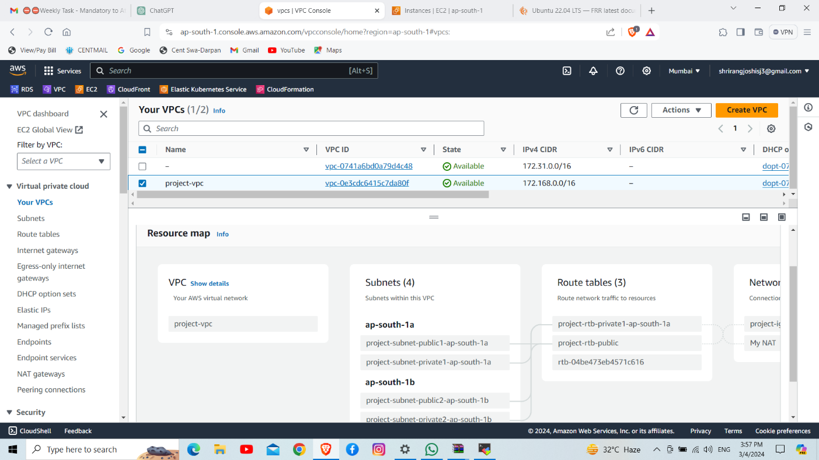

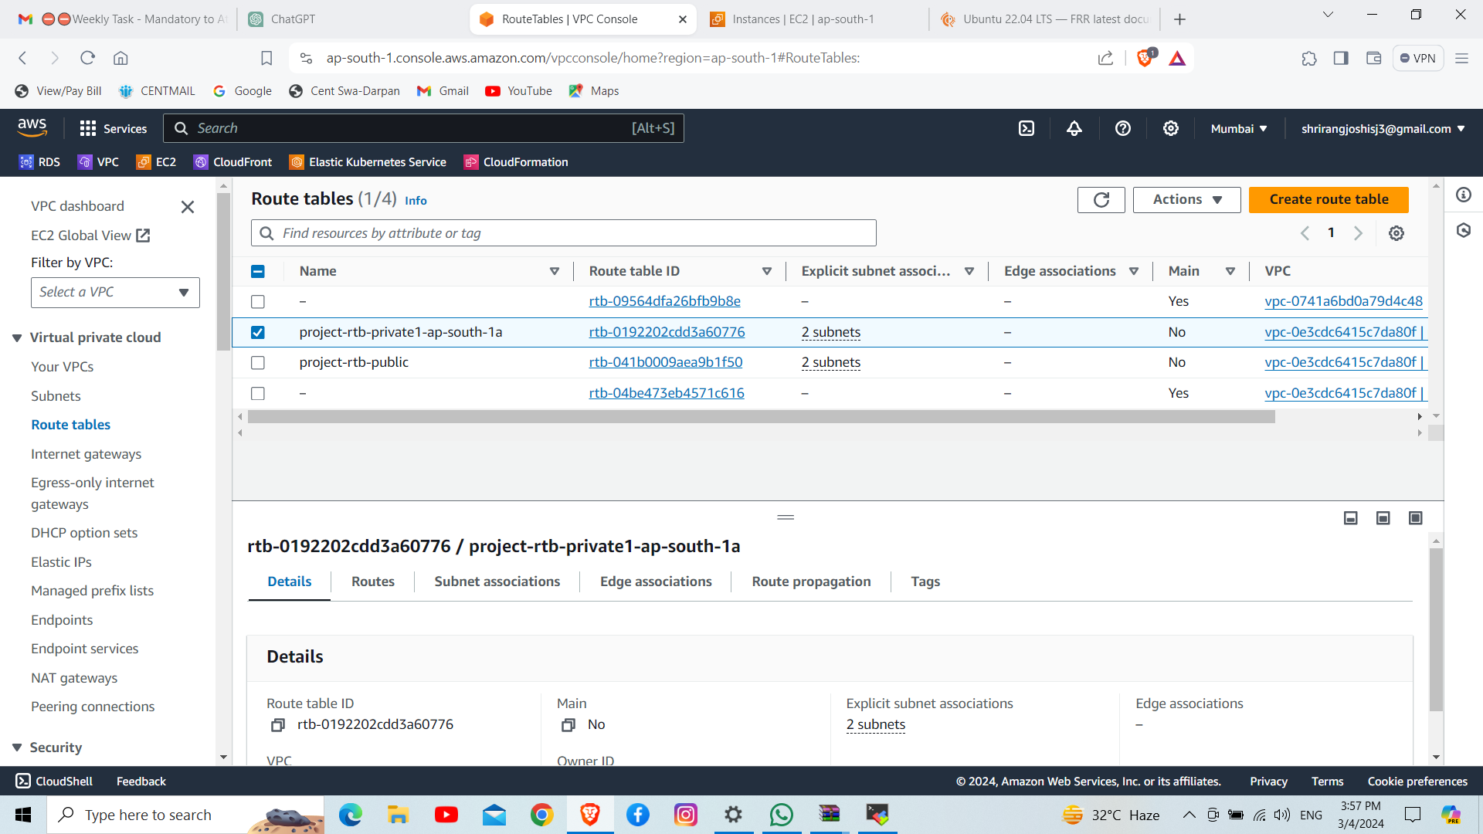

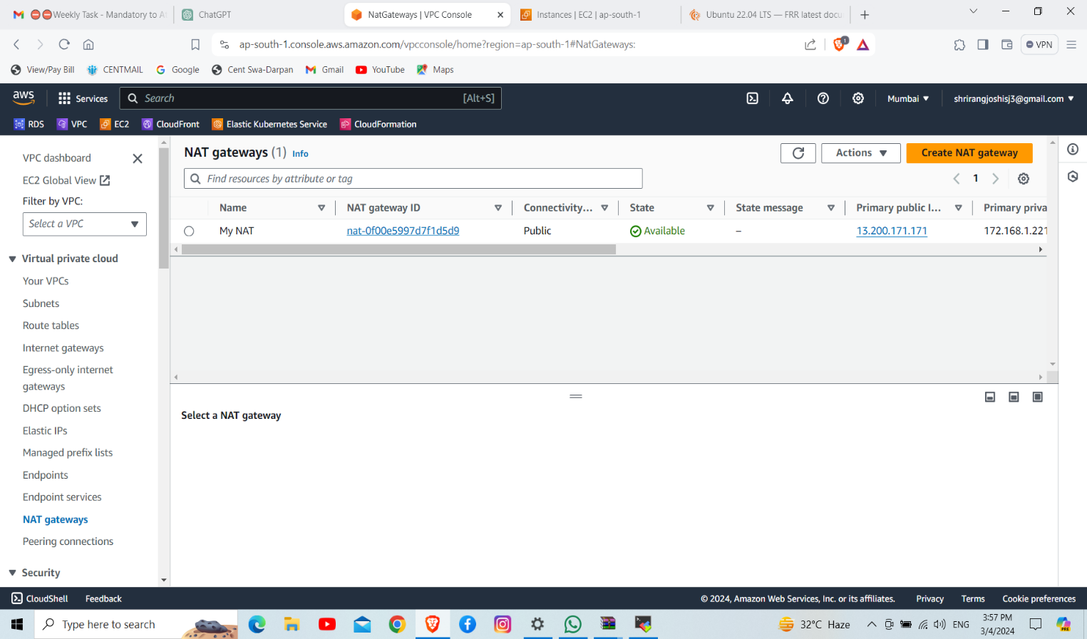

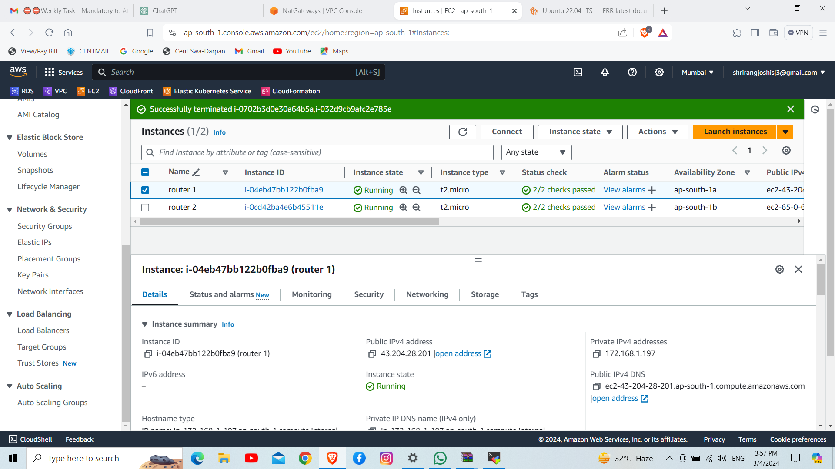

**Step2. Firewall setup**

1. For firewall setup we set security group within our IP
2. Use NACL for vpc

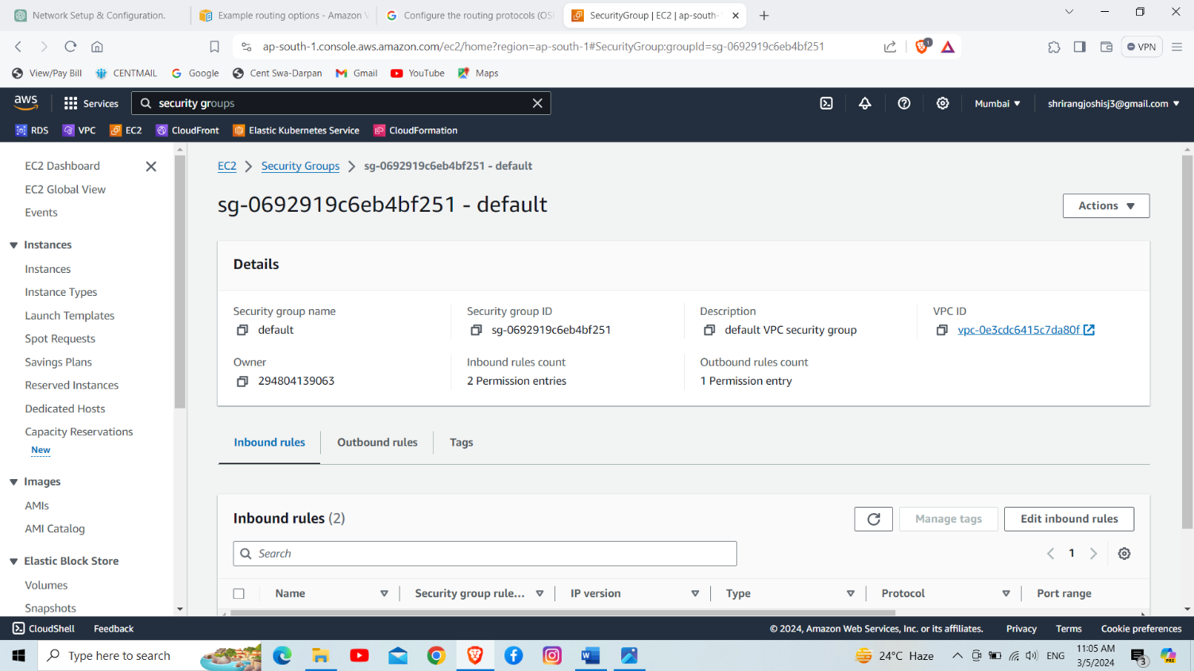

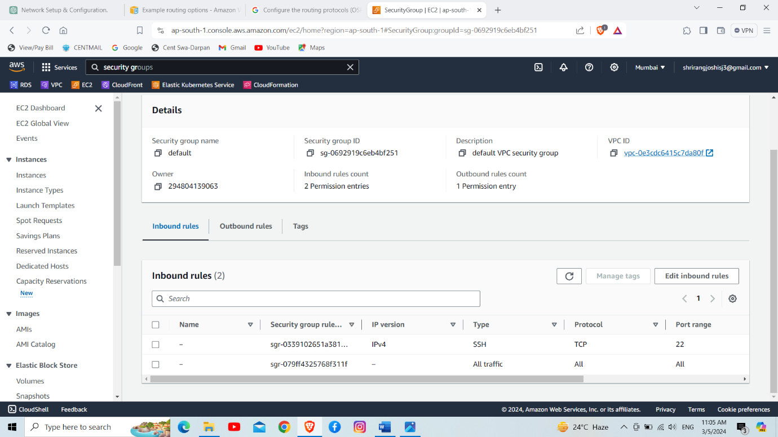

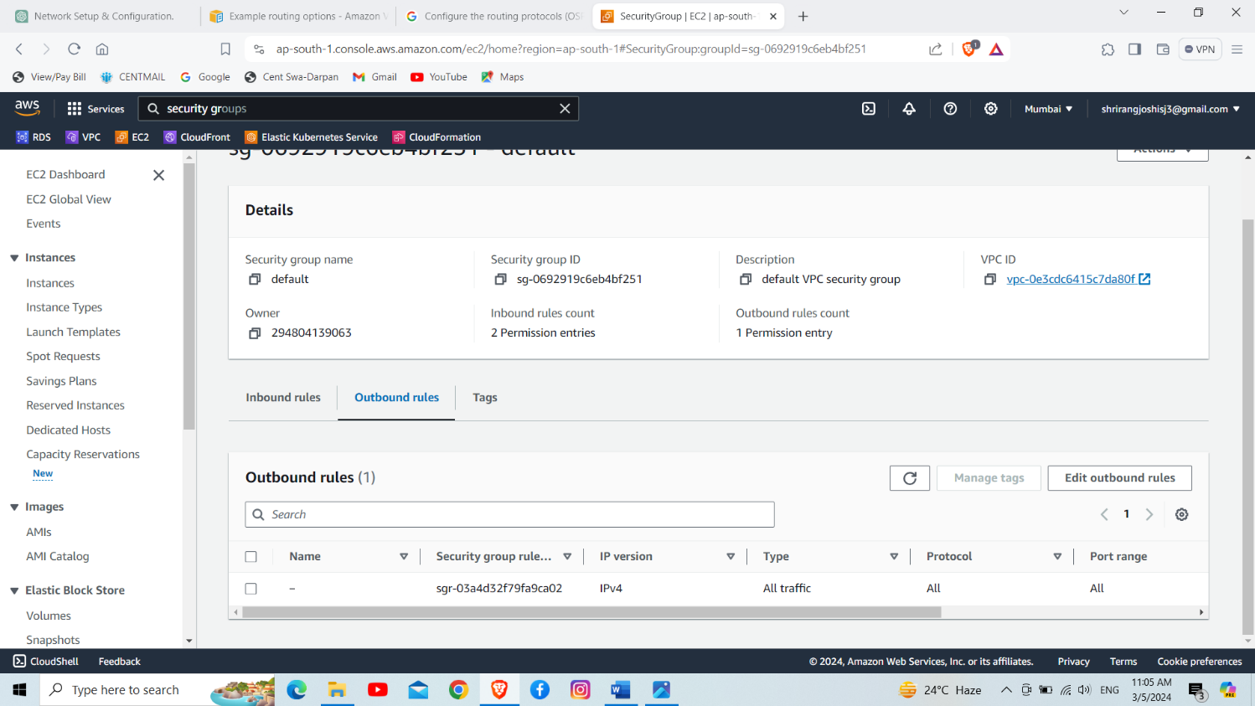

**Step3. Load balancer configuration**

1. We use application load balancer
2. Setup the target groups and create a load balancer
3. While creating a load balancer we setup an health check algorithm

